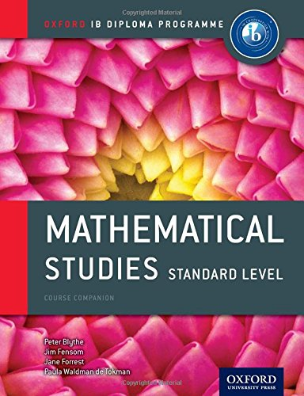
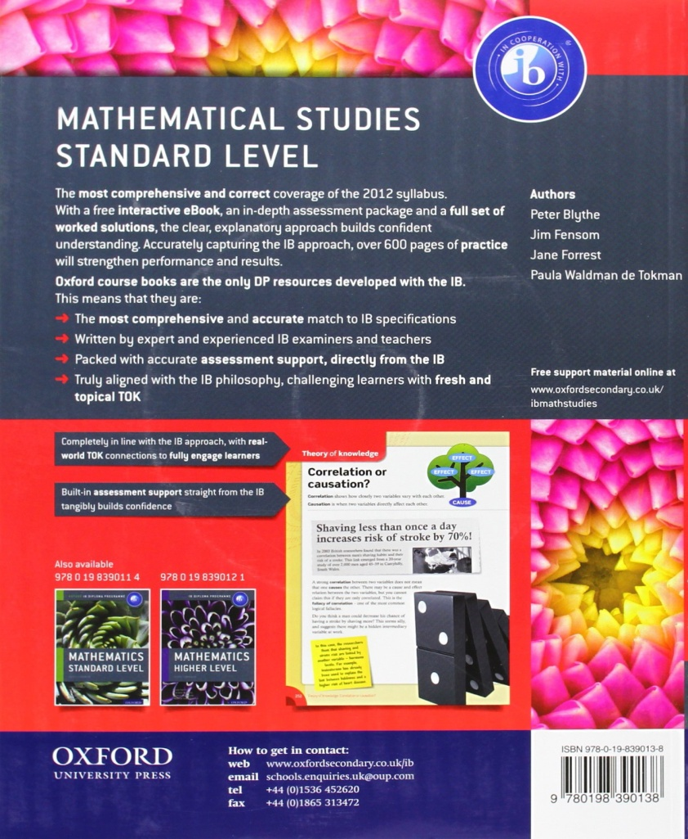
You will need to buy your textbook. IB Mathematical Studies Standard Level Course Book: Oxford IB Diploma Program (Oxford Ib Diploma Programme) Paperback – October 25, 2012

• Series: Oxford Ib Diploma Programme
• Paperback: 624 pages
• Publisher: Oxford University Press; 2 edition (October 25, 2012)
• Language: English
• ISBN-10: 0198390130
• ISBN-13: 978-0198390138

